Gossip Protocol Implementation

Varun Reddy Regalla(4143-6018)

Sai Tarun Damacharla(4174-0254)

A gossip is just like passing a rumor to each and every node in a network and any node can receive a message any number of times. In this implementation, we have selected and node at random and we have sent rumor to all the adjacent nodes associated with that node in random and this process continues recursively. When a particular node receives a rumor for the 10th time, the rumor transmission is terminated. After the convergence is achieved, the program is terminated and prints the convergence time.

PushSum:

In push-sum, we have selected a node in random in a particular network and it start sending the rumor to its adjacent nodes. When a particular node sends the rumor, the sender weights is reduced by (s/2, w/2) and the receiver weight is increased by (s/2,w/2). The convergence happens when the s/w ratio has not changed for a factor of 10^-10 for three consecutive times. Once the convergence is acheived, the program terminates and prints the convergence time.

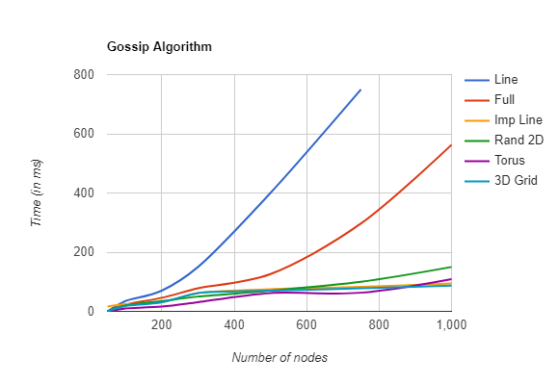

From the graph plotted between the convergence time and different topologies, we can derive the following inferences:

* 3D and Torus has the better performance for nodes and it has the least convergence time for those number of nodes
* Line topology has the least performance and also it has the highest convergence time for the given number of nodes. It increases exponentially once the number of nodes increases
* Full topology has a good performance for the nodes less than 200 and it goes exponentially as the number of nodes increases and it has the least convergence time
* 2D topolgy has a good performance as the number if nodes increases. Its convergence time is better when it contains more number of nodes than the other topologies

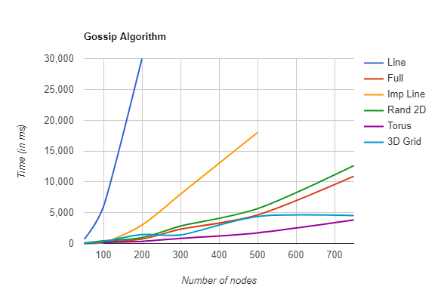

From the graph plotted between the convergence time and different topologies, we can derive the following inferences:

* Torus and 3D has the better performance for nodes and it has the least convergence time for those number of nodes
* Line topology has the least performance and also it has the highest convergence time for the given number of nodes. It increases exponentially once the number of nodes increases
* Imperfect Line topology has best performance for the nodes less than 100 and it goes exponentially as the number of nodes increases and it has the least convergence time
* Full topolgy has got 2nd best performance after Imperfect line and as the nodes increases the convergence time goes exponentially
* 2D topolgy has a good performance as the number if nodes increases. Its convergence time is better when it contains more number of nodes than the other topologies